Reg. No: 192411129

Programme : B. E / B. tech
Course Code : CSA43
Course Name : Internet programming
Problem Statement (Assignment) Max Marks: 100
Field | Content
Assignment Title | Smart Campus Service Management System
Course Outcome(s) – CO | CO1: Develop visually appealing web pages using CSS for layout and style, and create dynamic, interactive functionality with JavaScript.  CO2: Build dynamic web applications using XML, XSLT, and JSP within the MVC paradigm for efficient data handling and presentation.
Bloom’s Taxonomy Level | L3 – Apply | L4 – Analyze | L5 – Evaluate | L6 – Create
SDG Mapping (SDG 1–17) | SDG 9 - Industry, Innovation and Infrastructure, SDG 4 -  Quality Education
Problem Statement
A university currently relies on manual communication such as emails, phone calls, and paper-based records for reporting and resolving campus service issues. This approach makes it difficult to efficiently record complaints, assign requests to the appropriate service personnel, monitor progress, and provide timely status updates to students and faculty.

The university therefore proposes to develop a Smart Campus Service Management System as an integrated web-based application. The system shall enable students and faculty to submit service requests related to laboratory equipment faults, network problems, classroom maintenance, library services, and other technical issues through a web browser. Users should be able to provide relevant details, submit requests, and subsequently track the status of their requests.
The proposed system should demonstrate an integrated client-server web architecture. The client side shall provide an interactive and user-friendly interface using HTML/XHTML, CSS, JavaScript, and DOM. The server side shall process requests using Java Servlets and JSP, following the MVC architecture. XML shall be used for structured data representation, and XSLT shall be used to transform XML data for presentation where appropriate.

Problem Identification (10 Marks)-The university relies on manual communication (emails, phone calls, paper records) for reporting and resolving service issues, which causes inefficiency in recording complaints, assigning requests, monitoring progress, and providing timely updates.
Proposed Solution -Develop a Smart Campus Service Management System (10 Marks), a web-based application that allows students and faculty to submit service requests (lab equipment faults, network problems, classroom maintenance, library services) and track their status online.
System Design & Architecture - Data Representation (20 Marks) -Implement an integrated client-server web architecture. The client side should use HTML/XHTML, CSS, JavaScript, and DOM for interactivity, while the server side should use Java Servlets and JSP following the MVC model. Use XML for structured data representation for transforming XML data into user-friendly formats for presentation and reporting.
Implementation & Testing (10 Marks) -Demonstrate request submission, assignment to service personnel, progress tracking, and timely updates. Validate inputs, handle errors, and ensure smooth user experience.

STG Goals –SDG 9 - Industry, Innovation and Infrastructure, SDG 4 - Quality Education

Requirement Analysis (SDG 9 – Industry, Innovation & Infrastructure) Identify inefficiencies in manual reporting and propose a digital infrastructure for service management.
Client Interface Development (SDG 4 – Quality Education) Build user-friendly web forms and dashboards so students/faculty can easily submit and track requests, improving access to campus services.
Assessment Criterion | CO Mapping | Weightage / Marks
Problem understanding & formulation | CO1 | 10
Application of course/domain knowledge | CO2 | 20
Solution methodology / design / implementation | CO3 | 20
Use of appropriate modern tools / techniques | CO4 | 10
Results, testing & validation | CO4 / CO5 | 15
Analysis, trade-offs & justification | CO5 | 15
Broader considerations / professional responsibility, where applicable | CO5 | 5
Technical documentation & reflection | CO1–CO5 | 5
TOTAL |  | 100

Performance Level | CO Attainment Percentage | Interpretation
Level 3 | ≥ 70% | CO Attained
Level 2 | 60–69% | CO Moderately Attained
Level 1 | 50–59% | CO Minimally Attained
Level 0 | < 50% | CO Not Attained

Code of Conduct
I N. Meghana (192411129) certify that this submission is my original work and that I have adhered to the guidelines specified for this assessment. I understand that any violation of academic-integrity rules will result in disciplinary action.

Signature of the Student: N. Meghana
_____________________  Faculty In-charge  Name:  Date: | _____________________  Course Coordinator  Name:  Date: | _____________________  Head of Department  Name:  Date:

1. PROBLEM IDENTIFICATION
The university currently uses several manual methods for reporting service problems, including email, telephone calls and paper-based records. Although these methods can communicate an issue, they do not provide a common tracking mechanism. A student may report a laboratory problem to one person while a faculty member reports a similar issue through another channel. Information can therefore become scattered across different people and records.
The absence of centralized tracking creates several practical difficulties. It can be difficult to know whether a complaint has been received, who is responsible for it, whether work has started and when the issue is expected to be completed. Urgent problems may also be mixed with routine requests. When a user wants an update, another call or email may be necessary.
The proposed system solves this problem by creating one digital workflow for campus service requests. Every request is recorded with a unique request ID, category, location, priority, description and current status. Authorized personnel can assign the request and update its progress. The user can then track the request from the same web interface.
The central problem is therefore the lack of an organized service-management infrastructure rather than simply the absence of a web page. The system must connect reporting, assignment, progress tracking and resolution into one process.
2. PROPOSED SOLUTION
The Smart Campus Service Management System is a browser-based application designed for students and faculty to report campus service issues. The system can handle laboratory equipment faults, network problems, classroom maintenance, library-related services and other technical issues identified by the university.
A user first accesses the application through a web browser and logs in. After authentication, the user can open a service-request form and provide the required details. Once the request is submitted, the server validates the information and creates a unique request ID. The request is then made available to the appropriate service department or employee.
Service personnel can view assigned requests, change their status and add progress or resolution remarks. The user can return to the dashboard to see the latest information. This reduces the need for repeated calls and emails because the request record itself becomes the main source of status information.
The solution follows the client-server architecture required in the assignment. HTML/XHTML and CSS form the client interface, while JavaScript and DOM provide interactive behaviour. Java Servlets handle request processing, JSP provides dynamic presentation, XML represents structured information and XSLT can transform XML data into a readable presentation.
3. OBJECTIVES
• Create a single online platform for campus service complaints.
• Make request submission simple for students and faculty.
• Assign requests to the correct service personnel or department.
• Provide a unique identifier for every accepted request.
• Allow users to track the progress of their requests.
• Allow service personnel to update status and resolution details.
• Reduce paper records and repeated communication.
• Demonstrate the Internet Programming technologies listed in the assignment.
• Apply MVC principles to separate data, processing and presentation.
• Support the SDG 9 and SDG 4 goals identified in the assignment.
4. STAKEHOLDERS AND USER ROLES
4.1 Student
Students can register, log in, submit service requests and track the requests associated with their accounts. They can provide the location of a problem and describe how it affects their work. Students should not be allowed to change staff-only information such as assignment or official resolution status.
4.2 Faculty
Faculty members can use the same request mechanism to report problems affecting classrooms, laboratories, networks and other academic facilities. Their requests can be tracked through the dashboard in the same way as student requests.
4.3 Service Personnel
Service personnel are responsible for handling assigned complaints. They can open request details, begin work, update progress and add remarks. They can mark an issue as resolved when the required work has been completed.
4.4 Administrator
The administrator manages users, service categories, assignments and overall request information. Administrative access should be protected because it can affect the records of many users.
5. REQUIREMENT ANALYSIS
5.1 Functional Requirements
• User registration and account creation.
• Secure login and logout.
• Service-request submission.
• Selection of service category and priority.
• Entry of problem location and detailed description.
• Generation of a unique request ID.
• Viewing of personal request history.
• Assignment of requests to service personnel.
• Updating of request status.
• Recording of progress and resolution remarks.
• Filtering requests by status, category or priority.
• Validation of user input.
• Meaningful error and confirmation messages.
5.2 Non-Functional Requirements
• Usability: users should understand the forms and navigation without extensive training.
• Performance: common operations should respond without unnecessary delay.
• Reliability: accepted requests should remain available for later tracking.
• Security: access to user and staff functions should depend on authorization.
• Maintainability: components should remain separated according to the MVC approach.
• Scalability: new departments and service categories should be easy to add.
• Compatibility: the interface should work in commonly used modern browsers.
6. SYSTEM DESIGN AND ARCHITECTURE
The proposed system uses a client-server structure. The browser is the client and provides the interface through which users submit and view requests. The server receives those requests, validates the information and performs the required processing. The response is then returned to the browser.
The MVC model provides an organized way to build the server-side application. The Model represents request and user data. The Controller, implemented with Java Servlets, receives HTTP requests and controls the application flow. JSP pages form the View and display information to users.
The overall flow can be represented as:
Browser → Servlet Controller → Model/Data Processing → JSP View → Browser
JavaScript and DOM work mainly on the client side, while the server remains responsible for trusted validation and processing.
6.1 Main Architecture Components
• Browser: runs the client interface.
• HTML/XHTML: creates page structure and forms.
• CSS: controls layout and visual presentation.
• JavaScript: performs client-side interaction and basic validation.
• DOM: allows JavaScript to read and change page elements.
• Java Servlets: receive and process requests.
• JSP: generates dynamic pages using processed information.
• XML: stores or exchanges structured service-request information.
• XSLT: transforms XML into a user-readable presentation or report.
7. DETAILED MODULE DESIGN
7.1 Authentication Module
The authentication module controls access to the application. A registration page can collect basic user details, while the login page verifies credentials before providing access to the dashboard. After successful login, the server can maintain a session so that the user remains authenticated while moving between pages.
Role information is important because a student or faculty member should not have access to administrative functions. The system can distinguish between normal users, service personnel and administrators. Logout should invalidate the active session.
7.2 Service Request Module
This is the main module of the application. It collects the information needed to understand and process a campus problem. A request can contain an ID, requester, category, location, priority, description, date, assigned employee, status and remarks.
The category helps route a request. A network complaint can be directed to network support, while a classroom maintenance issue can be directed to the facilities team. Priority allows staff to identify requests that may have a greater effect on academic activities.

7.3 Tracking Module
The tracking module displays requests belonging to the logged-in user. A dashboard can show the request ID, category, date, priority and current status. Selecting an individual request can display its description, assignment and latest remarks.
This feature directly addresses the original tracking problem. Users do not need to contact staff repeatedly just to ask whether their request has been received or processed.
7.4 Service Personnel Module
Service personnel can view requests assigned to their department or account. They can update the status when work begins, add progress information and record the final resolution. This creates a traceable workflow from submission to completion.
7.5 Reporting Module
The reporting module can organize request information by category, priority, status or department. XML can provide structured input to a report and XSLT can transform that data into an HTML-style presentation. Such reports can help administrators identify frequently occurring problems.
8. CLIENT INTERFACE DEVELOPMENT
The client interface should be simple and task-oriented. The main pages can include a home page, registration page, login page, dashboard, service request form, request-details page and staff dashboard.
8.1 HTML/XHTML
HTML/XHTML provides the structure of the application. Forms can contain input fields, selection controls, text areas and buttons. Tables can display request records, while navigation links connect the different pages.
8.2 CSS
CSS is used to create a consistent visual design. It can define the width of forms, spacing between controls, typography, table appearance, buttons and dashboard sections. Consistency is important because users should recognize the same actions throughout the application.
8.3 JavaScript
JavaScript adds behaviour to the interface. It can check required fields before submission, display validation messages and respond to user actions. For example, when a user selects a service category, JavaScript can update related information on the page.
8.4 DOM
The Document Object Model represents the page as objects that JavaScript can access. DOM operations can be used to change text, show or hide messages, update a status element or modify form content without rebuilding the entire page.
9. JSP AND JAVA SERVLETS
Java Servlets act as controllers in the proposed MVC architecture. When the browser sends a service-request form, the Servlet receives the request parameters, checks them and performs the required operation. It can then forward the result to a JSP page.
JSP is used for dynamic presentation. A single JSP page can display different request details depending on the data supplied by the controller. This avoids creating a separate static page for every request.
The separation between Servlets and JSP improves maintainability. Business decisions remain in the server-side processing layer, while JSP concentrates on displaying information. CSS can independently control the appearance of those pages.
10. XML DATA REPRESENTATION
XML provides a structured representation of service information. It uses named elements to describe each value, making the data understandable to both people and software. For this project, XML can represent a single request or a collection of requests.
A collection may use a root element called serviceRequests and contain several serviceRequest elements. Each request can include requestId, category, location, priority, status and description. This structure demonstrates the assignment requirement for XML-based data representation.
10.1 Sample XML
<serviceRequests>
<serviceRequest>
<requestId>SCM1025</requestId>
<category>Network</category>
<location>Computer Lab 2</location>
<priority>High</priority>
<status>In Progress</status>
<description>Network connection is unstable.</description>
</serviceRequest>
<serviceRequest>
<requestId>SCM1026</requestId>
<category>Classroom Maintenance</category>
<location>Room B204</location>
<priority>Medium</priority>
<status>Assigned</status>
<description>Ceiling fan is not operating properly.</description>
</serviceRequest>
</serviceRequests>
11. XSLT TRANSFORMATION
XSLT is used to transform XML information into another presentation format. In this system, an XSLT stylesheet can read the serviceRequest elements and generate an HTML table. Each XML value can be placed into the appropriate table column.
For example, requestId can appear under Request ID, category under Category, priority under Priority and status under Status. The resulting table can be displayed in a browser and used as a simple service report.
The important advantage is the separation between information and presentation. XML describes the data, while XSLT controls how the data is shown. This demonstrates the XML and XSLT concepts required by the assignment.

12. REQUEST LIFE CYCLE
• Submitted – the request has been successfully registered.
• Assigned – the request has been given to the appropriate service person or department.
• In Progress – work has started.
• Resolved – the reported issue has been addressed.
• Closed – the request has reached its final stage.
The status sequence gives the user a clear understanding of what is happening. It also gives administrators a simple way to identify requests that are still waiting for action.
13. COMPLETE REQUEST WORKFLOW
1. The user opens the application in a browser.
2. The user logs in with valid credentials.
3. The dashboard displays existing requests.
4. The user chooses the option to create a service request.
5. The user selects a category and enters location, priority and description.
6. JavaScript checks required fields on the client side.
7. The browser sends the information to the Servlet.
8. The Servlet validates the data on the server.
9. The system creates a unique request ID.
10. The request is stored with Submitted status.
11. An authorized person assigns the request.
12. The status becomes Assigned.
13. When work begins, the status changes to In Progress.
14. Service personnel record useful progress remarks.
15. After the issue is corrected, the request is marked Resolved.
16. The user can view the resolution details.
17. The request is finally Closed.
14. INPUT VALIDATION AND ERROR HANDLING
Validation ensures that service requests contain enough information for staff to act on them. Required fields such as category and description should be checked before submission. Invalid values should not be accepted simply because they were sent from a browser.
Client-side validation provides fast feedback to the user, but it is not sufficient for security. A user can bypass JavaScript, so the Servlet must repeat important validation on the server. The server should verify that the submitted values are acceptable before storing or processing them.
Error messages should be simple and useful. Instead of exposing technical exception details, the application can display messages such as 'Please enter the problem description' or 'The request could not be submitted. Please try again.' Detailed technical errors can be recorded separately for authorized administrators.
15. SECURITY CONSIDERATIONS
Security is important because the system handles user accounts and service information. Authentication should be required for protected pages, and authorization checks should be applied before staff or administrator operations are performed.
The server should never rely only on hidden buttons or client-side restrictions. A user could manually send a request to a protected operation, so the Servlet must check the user's role before carrying out the action.
User input should also be validated carefully. If the application is later connected to a database, parameterized queries should be used. Passwords should be stored using secure password-hashing methods rather than plain text.
16. IMPLEMENTATION METHODOLOGY
1. Create the Java web project and organize the MVC components.
2. Design the main HTML/XHTML pages.
3. Create a common CSS stylesheet for consistent presentation.
4. Implement registration, login and logout.
5. Develop the service request form.
6. Add JavaScript validation and DOM interaction.
7. Create Servlets for request submission and tracking.
8. Create JSP pages for dashboards and request details.
9. Define the XML structure for service requests.
10. Create an XSLT stylesheet for report transformation.
11. Integrate all modules and test the complete request life cycle.
17. SAMPLE REAL-WORLD SCENARIO
Suppose a student is attending a practical session in Computer Lab 2 and discovers that several systems cannot connect to the campus network. Instead of calling a support employee, the student opens the Smart Campus Service Management System and submits a Network request.
The student enters Computer Lab 2 as the location, selects High priority because the problem affects laboratory work, and describes the unstable connection. After validation, the system generates request ID SCM1025 and marks it Submitted.
The network support team sees the request and assigns it to a technician. Its status becomes Assigned and later In Progress. The technician checks the network equipment and resolves the issue. A short resolution remark is added and the status becomes Resolved. The student can see the result through the dashboard.
This scenario shows the practical value of the proposed system: the complete interaction is recorded in one place, and both the requester and service team have a clear view of the request.
18. IMPLEMENTATION AND TESTING
Testing should cover individual modules as well as the complete workflow. Valid and invalid inputs should both be considered. The purpose is to verify that the application performs the required functions and handles incorrect actions safely.
Test Case | Input / Action | Expected Result | Status
Registration | Valid user details | Account is created | Pass
Login | Valid credentials | Dashboard opens | Pass
Invalid login | Incorrect password | Access is rejected | Pass
Request submission | Complete request details | Unique request ID is generated | Pass
Missing field | Description left empty | Validation message is shown | Pass
Assignment | Authorized staff assigns request | Status becomes Assigned | Pass
Progress update | Staff begins work | Status becomes In Progress | Pass
Resolution | Staff completes work | Status becomes Resolved | Pass
Tracking | User opens request | Latest status is displayed | Pass
Access control | Normal user tries staff action | Operation is denied | Pass
XML | Read structured request data | Elements are processed correctly | Pass
XSLT | Transform XML report | Readable report is generated | Pass
19. RESULTS AND VALIDATION
The proposed system can be validated by following a request from creation through closure. The most important outcome is traceability. A request is no longer an isolated email or paper entry; it becomes a record with an ID, owner, status and history.
Input validation improves the quality of submitted information. Assignment ensures that requests reach the appropriate personnel, while status updates allow users to understand progress. XML and XSLT provide the required structured data and transformation functions.
For an actual university deployment, additional load, security, usability and compatibility testing would be required. The tests included here are intended to validate the main functional design and the Internet Programming concepts specified in the assignment.
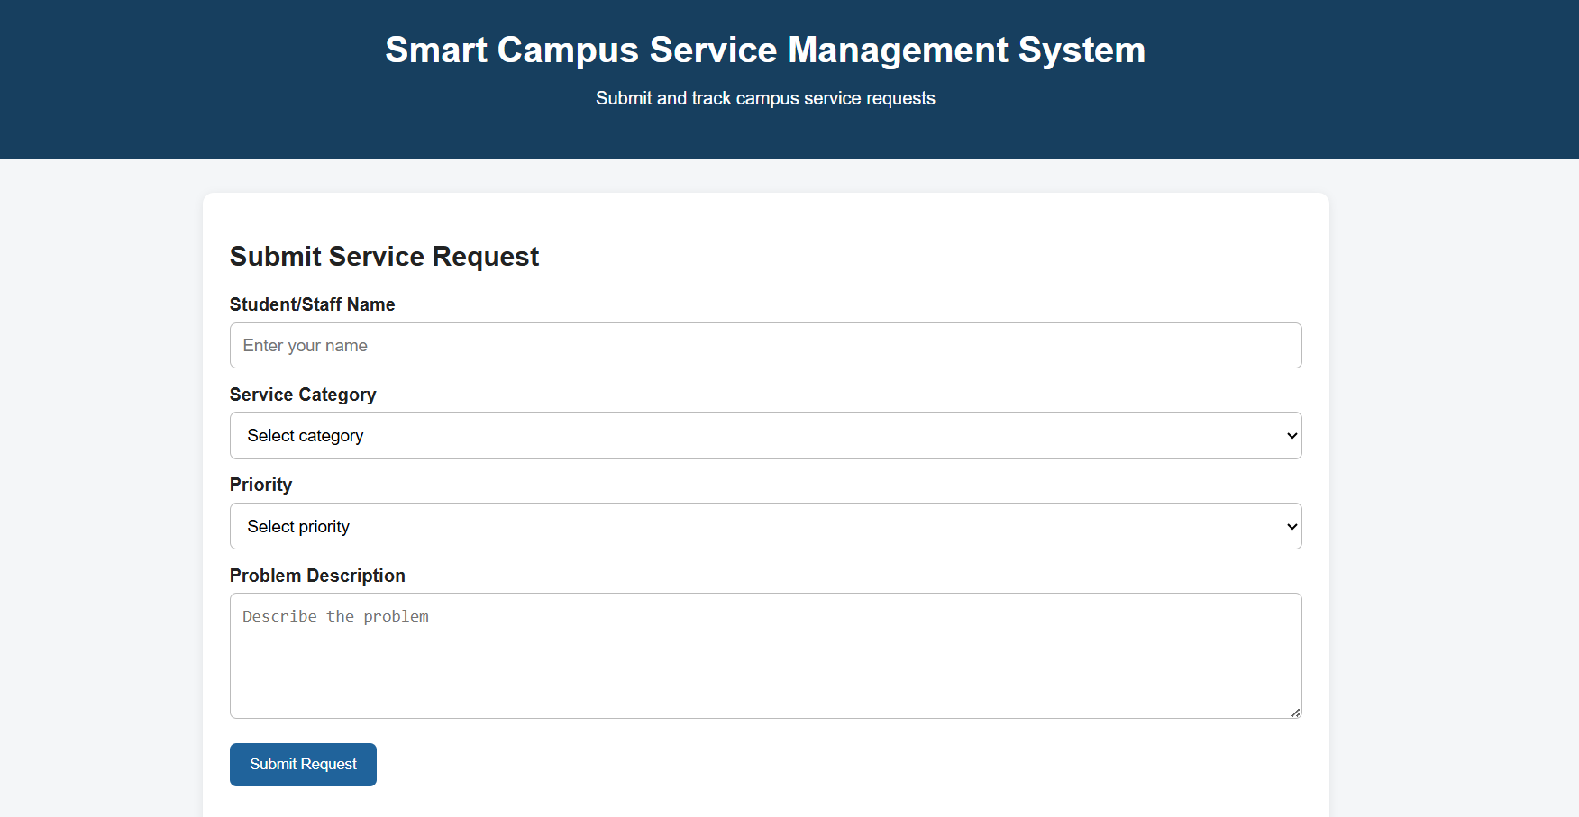

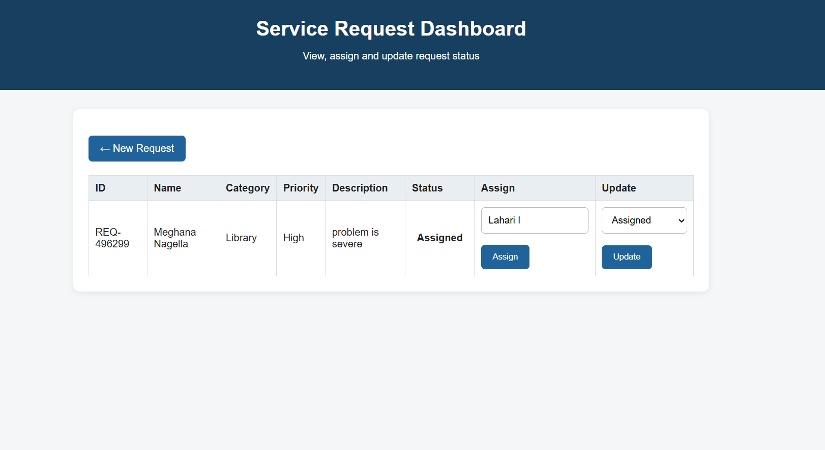
20. ANALYSIS, TRADE-OFFS AND JUSTIFICATION
A browser-based system is suitable because users can access it from computers already available on campus. It avoids the need to install a separate desktop application. The main dependency is network availability, which is reasonable for a campus web service.
XML is useful for demonstrating structured information and data transformation. However, a large production system would normally use a database for frequent updates, searches and concurrent transactions. XML can still be useful for data exchange or reporting.
JavaScript improves usability by providing immediate feedback, but it cannot be trusted as the only validation layer. Server-side validation is therefore necessary. Similarly, MVC requires more separation than placing all code in a single JSP page, but this additional structure makes the application easier to maintain.
The proposed technologies are justified because they directly match the technologies specified in the assignment: HTML/XHTML, CSS, JavaScript, DOM, Java Servlets, JSP, XML and XSLT.
21. SDG 9 – INDUSTRY, INNOVATION AND INFRASTRUCTURE
The assignment maps the project to SDG 9 because the system introduces digital infrastructure for managing campus services. Instead of relying on disconnected communication methods, the university gains a structured platform for recording and monitoring infrastructure-related problems.
The system can improve operational visibility. When many requests are collected in one place, administrators can identify categories that occur frequently, observe unresolved requests and understand where additional attention may be needed.
The project also represents a small-scale digital innovation. It combines client-side and server-side technologies to solve an institutional problem rather than using technology only as a demonstration.
22. SDG 4 – QUALITY EDUCATION
The assignment also maps the project to SDG 4. Students and faculty depend on functional laboratories, classrooms, networks and library services to participate effectively in academic activities.
The system supports the educational environment by making it easier to report problems and follow their progress. When service issues are visible and properly assigned, responsible teams can respond more systematically.
The contribution to SDG 4 is therefore indirect. The application does not provide teaching content; instead, it improves access to the supporting services and infrastructure required for a better learning environment.
23. PROFESSIONAL RESPONSIBILITY
A campus service application should be designed responsibly because it may contain personal details and information about university facilities. Only information needed for service management should be collected, and access should be limited according to user roles.
Status information should also be accurate. A request should not be marked Resolved unless the reported problem has actually been addressed. Clear status definitions and meaningful remarks improve trust in the application.
Accessibility should be considered during interface development. Forms should have clear labels, navigation should be understandable, and important information should not depend only on colour. These practices make the application easier to use for a broader group of users.
24. FUTURE ENHANCEMENTS
• Email or in-system notifications when a request is assigned or resolved.
• Automatic escalation of high-priority requests that remain unresolved.
• Dashboard charts for category, priority and resolution trends.
• Database integration for larger volumes of service records.
• Attachment support for photographs of damaged equipment.
• Improved mobile-responsive interface.
• User feedback after request resolution.
• Advanced search by ID, date, category, location and department.
• Administrative performance reports.
• Integration with institutional authentication systems.
25. CONCLUSION
The Smart Campus Service Management System provides a practical digital solution to the manual reporting and tracking problems described in the assignment. It gives students and faculty a common method for submitting service requests and provides service personnel with a defined process for assignment, progress tracking and resolution.
The design uses HTML/XHTML, CSS, JavaScript and DOM for the client interface and Java Servlets and JSP for dynamic server-side processing. XML provides structured data representation and XSLT provides a way to transform that data into a readable report. MVC keeps the major responsibilities separated.
The project also demonstrates how Internet Programming can address a real institutional need. By improving the management of campus infrastructure and the accessibility of support services, the proposed system aligns with the assignment's SDG 9 and SDG 4 mapping.

26. REFLECTION
This assignment demonstrates that a useful web application requires more than creating individual pages. The interface must collect meaningful information, the server must process it correctly, and the user must be able to understand what happens after submission.
Working with the proposed architecture also shows why technologies have different responsibilities. HTML and CSS organize and present the interface, JavaScript and DOM improve interaction, Servlets control server-side processing, JSP presents dynamic information, and XML/XSLT support structured data and transformation.
The project therefore connects technical learning with a practical campus problem. The same design principles can be applied to many other service-management applications where users need to submit requests and track their progress.

